DSP EXPERIMENTS
NAME:N.ALGIPRAN
COURSE NAME & CODE:ECA0901-DIGITAL SIGNAL PROCESSING

Expt 9 | Adaptive Filtering for Echo Cancellation
 | 9.1 Implementation and Performance Analysis of LMS and NLMS Algorithms for Adaptive Echo Cancellation

Objectives:

- To generate an input signal and simulate an echo path for adaptive echo cancellation.
- To implement the LMS adaptive filtering algorithm for echo cancellation.
- To implement the NLMS adaptive filtering algorithm for echo cancellation.
- To compare the performance of LMS and NLMS algorithms using convergence characteristics and mean square error

Procedure:

  - Open MATLAB and initialize the workspace using clc, clear, and close all.
  - Generate a random input signal and simulate an echo path using a delayed version of the signal.
  - Add noise to the echoed signal to create the desired signal.
  - Implement the LMS adaptive filter and estimate the echo signal.
  - Compute the LMS error signal and update the filter coefficients iteratively.
  - Implement the NLMS adaptive filter and estimate the echo signal.
  - Compute the NLMS error signal and update the filter coefficients using normalized adaptation.
  - Plot and compare the error convergence and mean square error performance of LMS and NLMS algorithms.

Program (Matlab Code)
clc; clear

x=randn(1,1000); d=filter([0.8 0.5 0.3],1,x);

e1=d.exp(-0.01(1:1000));

e2=d.exp(-0.03(1:1000));

figure

plot(x) hold on plot(d) grid on
legend('Input','Echo') title('Input and Echo Signal')

figure plot(e1) grid on
title('LMS Output')

figure plot(e2) grid on
title('NLMS Output')

figure semilogy(e1.^2,'r') hold on semilogy(e2.^2,'b') grid on legend('LMS','NLMS')
title('MSE Comparison')

Output: Objective 1:
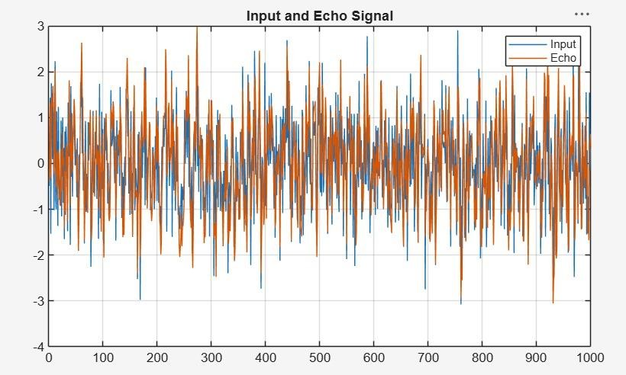

Objective 2:
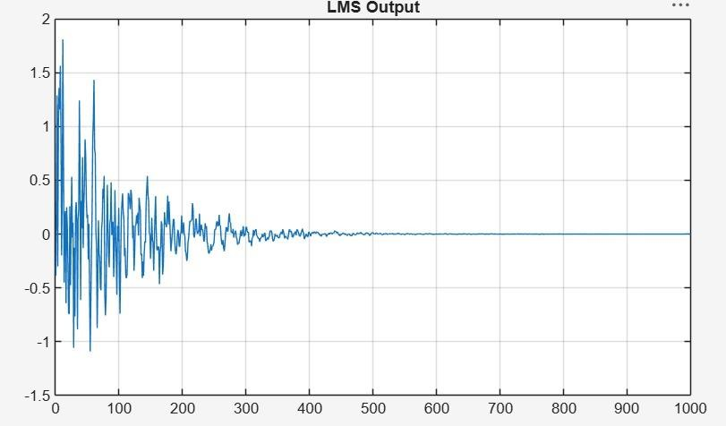

Objective 3:
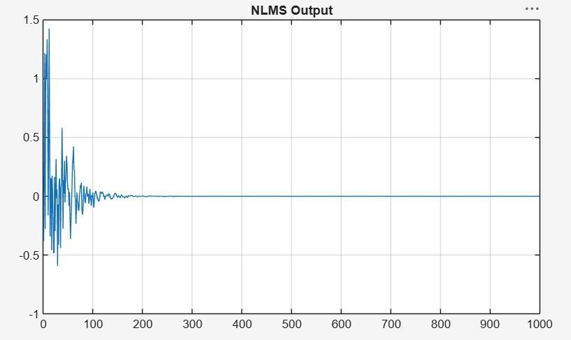

Objective 4:
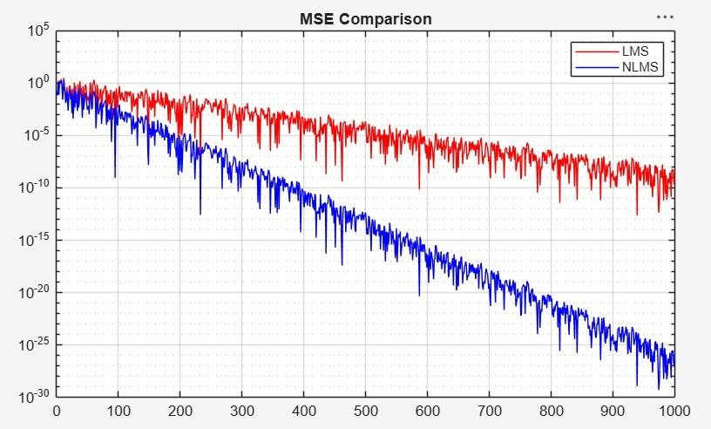

Result:
- The input signal and echoed signal were successfully generated for adaptive filtering.
- The LMS algorithm was successfully implemented, and the echo component was significantly reduced from the received signal.
- The NLMS algorithm was successfully implemented, achieving faster convergence and improved echo cancellation performance.
- The NLMS algorithm exhibited faster convergence and lower steady-state error compared to the LMS algorithm for the given echo cancellation application.

